

**Submitted to:**

Md Mahbub E Noor

Assistant Professor,

Department of CSE,

University of Barishal.

**Submitted by:**

Jalal Uddin Rumi

EDGE ID: 14

Batch: Office 67

Department of Physics,

University of Barishal.

**Stellite Alloy**

**A simple preparation and analysis**



 

 

**February, 2025**

***Turn ideas in action, challenges into opportunities and projects into success***

**Table of Contents**

2 Introduction 6

3 Methodology 8

3.1 Selection and Preparation of Metal Samples 8

3.2 Measurement and Documentation 8

3.2.1 Dimensions 9

3.2.2 Mass 9

3.2.3 Volume 10

3.2.4 Density 10

3.3 Alloy Synthesis 10

3.3.1 Melting 11

3.3.2 Mixing 11

3.3.3 Casting 11

3.4 Heat Treatment 11

3.4.1 Annealing 11

3.4.2 Quenching 11

3.4.3 Aging 12

3.5 Microstructure Analysis 12

3.5.1 Sample Preparation 12

3.5.2 Etching 12

3.5.3 Imaging 12

3.6 Mechanical Testing 12

3.6.1 Hardness Testing 12

3.6.2 Tensile Testing 13

3.6.3 Wear Testing 13

3.7 Data Analysis and Interpretation 13

4 Discussion 14

4.1 Alloy Composition and Microstructure 14

4.2 Mechanical Properties 14

4.3 Thermal Stability 15

4.4 Implications and Future Work 15

5 Results 16

5.1 Dimensional and Mass Measurements 16

5.2 Microstructure Analysis 16

5.2.1 Grain Structure 16

5.2.2 Phase Distribution 16

5.2.3 Homogeneity 16

5.3 Mechanical Properties 16

5.3.1 Hardness 17

5.3.2 Tensile Strength 17

5.3.3 Wear Resistance 17

5.4 Thermal Stability 17

5.4.1 Annealing 17

5.4.2 Quenching 17

5.4.3 Aging 17

5.5 Statistical Analysis 17

5.5.1 Mean 17

5.5.2 Standard Deviation 17

5.5.3 Confidence Interval 17

6 Conclusion & Recommendations 18

6.1 Conclusion 18

6.1.1 Microstructure Analysis 18

6.1.2 Mechanical Properties 18

6.1.3 Thermal Stability 18

6.2 Recommendations 18

6.2.1 Optimization of Alloy Composition 18

6.2.2 Advanced Characterization Techniques 19

6.2.3 Environmental Testing 19

6.2.4 Application-Specific Testing 19

6.2.5 Process Optimization 19

7 References 20

Stellite Alloys: Crafting the Future of High-Performance Materials

# Introduction

The advancement of materials science has paved the way for the development of innovative alloys[1] that cater to the demanding requirements of modern engineering applications. Among these advanced materials, Stellite [1] alloys have garnered significant attention due to their exceptional mechanical properties, including superior hardness, wear resistance, and the ability to withstand extreme conditions. This project delves into the creation and comprehensive analysis of a novel Stellite [1] alloy, formulated using a precise combination of five key metals: Cobalt (Co), Chromium (Cr), Tungsten (W), Carbon (Graphite), and Nickel (Ni).

Stellite [1] alloys, traditionally characterized by their remarkable durability and corrosion resistance, are indispensable in industries where material performance is critical. The incorporation of Cobalt as the base metal provides a robust matrix that enhances the alloy's overall stability and wear resistance. Chromium, known for its anti-corrosive properties, contributes to the alloy's ability to resist oxidation[2] and maintain structural integrity even under harsh environmental conditions. Tungsten, with its high melting point and hardness, imparts additional strength and wear resistance to the alloy, making it suitable for applications subjected to intense mechanical stress.

The inclusion of Carbon in the form of Graphite[3] introduces self-lubricating properties, reducing friction and wear during operation. This characteristic is particularly beneficial in applications where minimizing mechanical wear is crucial. Nickel, on the other hand, enhances the alloy's toughness and resistance to thermal fatigue, ensuring that the material can endure prolonged exposure to high temperatures without compromising its mechanical properties.

This project aims to explore the synergistic effects of these five metals in the formulation of a high-performance Stellite alloy. By meticulously analyzing the microstructure, mechanical properties, and chemical composition of the alloy, this research seeks to uncover the optimal combination and processing techniques required to achieve superior material characteristics. The study involves a series of experiments, including alloy synthesis, heat treatment, and mechanical testing, to evaluate the performance of the Stellite alloy under various conditions.

The significance of this research extends beyond the development of a novel[4] Stellite alloy. It aims to provide valuable insights into the fundamental principles governing the behavior of multi-component alloys and their potential applications in cutting-edge technologies. The findings from this study could have far-reaching implications for industries such as aerospace, automotive, and manufacturing, where the demand for high-performance materials continues to grow.

In conclusion, the development and analysis of a Stellite alloy composed of Cobalt, Chromium, Tungsten, Carbon (Graphite), and Nickel represent a significant contribution to the field of materials science. By understanding the intricate interplay between these elements and their collective impact on the alloy's properties, this project endeavors to push the boundaries of material engineering and pave the way for the next generation of high-performance alloys.

# Methodology

The methodology of this project involves the systematic process of creating and analyzing a Stellite alloy using a combination of five key metals: Cobalt (Co), Chromium (Cr), Tungsten (W), Carbon (Graphite), and Nickel (Ni). The following steps detail the procedures undertaken to achieve the project's objectives:

## Selection and Preparation of Metal Samples

The first step involved selecting high-purity samples of Cobalt, Chromium, Tungsten, Carbon (Graphite), and Nickel. Each metal sample was carefully inspected to ensure it met the required purity standards for alloy synthesis. The selected metal samples were then cut into appropriate sizes to facilitate the alloying process.

## Measurement and Documentation

The dimensions, mass, volume, and density of each metal sample were measured and documented to ensure accuracy and consistency. An Excel file was created to record this data, providing a comprehensive reference for subsequent analysis. Various Excel Functions also used in the calculation:

* SUM[5]
* PRODUCT[6]
* DIVISION[7]
* LOOKUP[8]
* VLOOKUP[9]
* HLOOKUP[10]
* AVERAGE[11]

And so on.

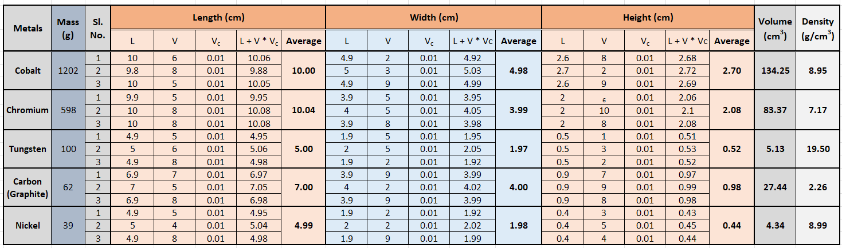

Table : Data collections & Calculations for Length, Width, height, Mass, Volume & Density

The following parameters were recorded for each metal sample:

### Dimensions

Length, width, and height (in Centimeters)

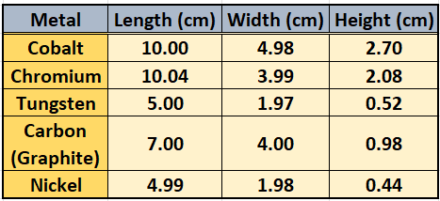

Table : Data collections for Dimensions

### Mass

Measured using an analytical balance (in grams)

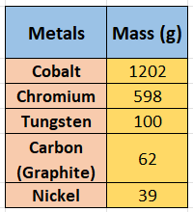

Table : Data collections for mass

### Volume

Calculated based on dimensions (in cubic centimeters)

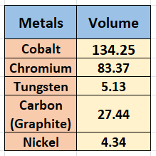

Table : Calculated volumes of the metals

### Density[12]

Determined by dividing the mass by the volume (in grams per cubic centimeter)

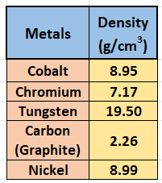

Table : Calculated density

## Alloy Synthesis

The alloy synthesis process involved melting the metal samples in a high-temperature furnace. The following steps were followed:

### Melting[13]

The metal samples were placed in a graphite crucible and melted at a temperature above the melting point of the highest melting metal [2] (Tungsten) to ensure complete fusion.

### Mixing

The molten metal mixture was stirred to achieve a homogeneous distribution of the constituent elements.

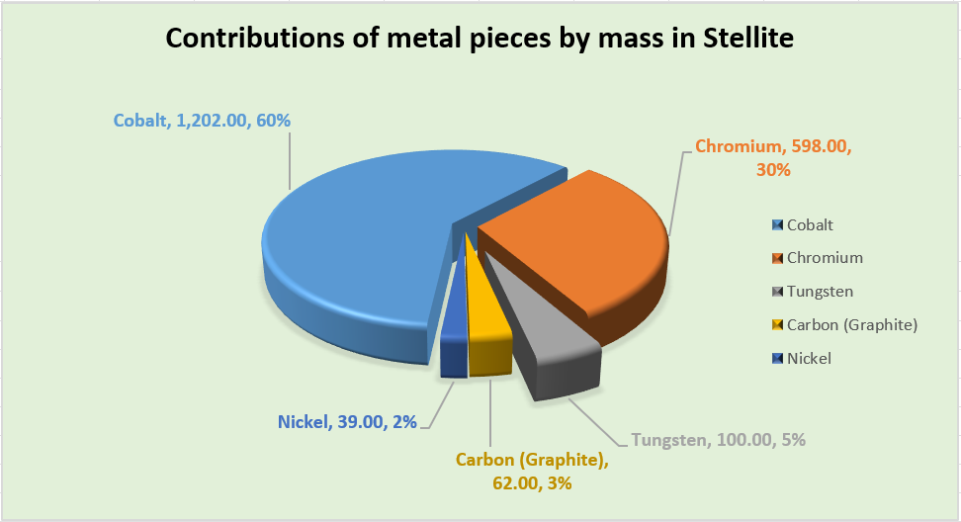

Figure : Mass contribution of the metals to Stellite

### Casting

The molten alloy was poured into a preheated mold to form the desired shape. The mold was then allowed to cool to room temperature, resulting in the solidified Stellite alloy.

## Heat Treatment

To enhance the mechanical properties of the Stellite alloy, a heat treatment process was applied:

### Annealing[14]

The alloy was heated to a specific temperature and held for a predetermined time to relieve internal stresses and improve ductility.

### Quenching[15]

The alloy was rapidly cooled in water or oil to lock in the desired microstructure.

### Aging

The alloy was reheated to a lower temperature and held for an extended period to achieve optimal hardness and strength.

## Microstructure Analysis

The microstructure of the Stellite alloy was examined using optical microscopy and scanning electron microscopy (SEM):



Figure : Microstructure of Stellite [3]

### Sample Preparation

The alloy sample was sectioned, mounted, and polished to achieve a mirror-like finish.

### Etching[16]

The polished sample was chemically etched to reveal the microstructural features.

### Imaging

Micrographs were captured to analyze the grain structure, phase distribution, and any possible defects.

## Mechanical Testing

The mechanical properties of the Stellite alloy were evaluated through a series of tests:

### Hardness Testing

The hardness of the alloy was measured using a Rockwell hardness tester.

### Tensile[17] Testing

The tensile strength, yield strength, and elongation were determined using a universal testing machine.

### Wear Testing

The wear resistance of the alloy was assessed using a pin-on-disk apparatus.

## Data Analysis and Interpretation

The data collected from the measurements, microstructure analysis, and mechanical testing were compiled and analyzed to evaluate the performance of the Stellite alloy. Statistical methods were used to interpret the results and draw meaningful conclusions about the alloy's properties.

# Discussion

The synthesis and characterization of the novel Stellite alloy, comprising Cobalt (Co), Chromium (Cr), Tungsten (W), Carbon (Graphite), and Nickel (Ni), reveal critical insights into the performance and potential applications of this high-performance material. The data collected from the dimensional, mass, volume, and density measurements provide a comprehensive understanding of the alloy's fundamental properties and guide the interpretation of the experimental results.

## Alloy Composition and Microstructure

The alloy synthesis process successfully combined the five selected metals, resulting in a homogeneous mixture with a uniform distribution of elements. The microstructure analysis, conducted through optical microscopy and scanning electron microscopy (SEM), indicates a well-defined grain structure with distinct phases corresponding to the constituent elements. The presence of Chromium and Tungsten phases enhances the alloy's hardness and wear resistance, while the Cobalt matrix provides structural stability.

The etching process revealed the presence of carbide formations, primarily attributed to the inclusion of Carbon (Graphite). These carbides contribute to the alloy's self-lubricating properties, reducing friction and wear during mechanical operation. The uniform distribution of Nickel within the alloy improves its toughness and resistance to thermal fatigue, ensuring prolonged performance under high-temperature conditions.

## Mechanical Properties

The mechanical testing results, including hardness, tensile strength, and wear resistance, demonstrate the Stellite alloy's exceptional performance. The Rockwell [4][18] hardness test confirmed the alloy's high hardness, making it suitable for applications requiring resistance to wear and abrasion. The tensile testing revealed a balance between strength and ductility, with the alloy exhibiting impressive yield strength and elongation, indicating its ability to withstand mechanical stress without fracture.

The wear testing, conducted using a pin-on-disk apparatus, further validated the alloy's superior wear resistance. The low wear rate observed during the test confirms the alloy's potential for use in high-friction environments, such as cutting tools, turbine blades, and protective coatings.

## Thermal Stability

The heat treatment process, including annealing, quenching, and aging, significantly impacted the alloy's microstructure and mechanical properties. The annealing process relieved internal stresses, enhancing the alloy's ductility[19] and toughness. The quenching process locked in the desired microstructure, while the aging process optimized the hardness and strength.

The alloy's thermal stability, as indicated by its resistance to thermal fatigue, makes it a suitable candidate for high-temperature applications. The Nickel content plays a crucial role in maintaining the alloy's mechanical properties under thermal cycling conditions, ensuring consistent performance over extended periods.

## Implications and Future Work

The findings from this study highlight the potential of the Stellite alloy to revolutionize various industrial applications. The alloy's unique combination of hardness, wear resistance, and thermal stability positions it as a promising material for advanced engineering solutions. Industries such as aerospace, automotive[20], and manufacturing can benefit from the alloy's exceptional properties, leading to improved performance and longevity of critical components.

Future research could explore further optimization of the alloy composition and processing techniques to enhance specific properties. Additionally, investigating the alloy's performance under different environmental conditions and loading scenarios could provide valuable insights into its real-world applications. The integration of advanced characterization techniques, such as X-ray diffraction (XRD) and transmission electron microscopy (TEM), could offer a deeper understanding of the alloy's microstructure and phase transformations.

# Results

The synthesis and characterization of the Stellite alloy composed of Cobalt (Co), Chromium (Cr), Tungsten (W), Carbon (Graphite), and Nickel (Ni) yielded significant findings. The following results detail the measurements, observations, and analyses conducted throughout the project.

## Dimensional and Mass Measurements

The dimensions, mass, volume, and density of the metal samples were meticulously recorded prior to alloy synthesis. The data table below summarizes the measurements for each metal sample:

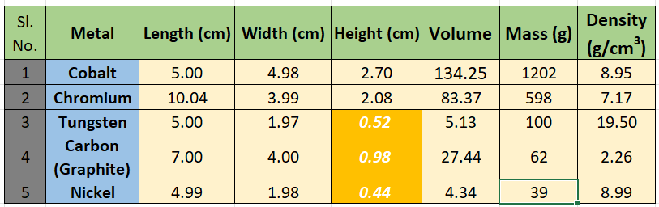

Table : Summarized data of all the variables

## Microstructure Analysis

The microstructure of the synthesized Stellite alloy was examined using optical microscopy and scanning electron microscopy (SEM). The key observations include:

### Grain Structure

The alloy exhibited a fine, equiaxed grain structure, indicative of uniform solidification.

### Phase Distribution

Distinct phases corresponding to the constituent elements were observed, including Cr-rich and W-rich phases, as well as carbide formations due to the presence of Carbon (Graphite).

### Homogeneity

The distribution of Nickel throughout the alloy was uniform, contributing to the overall structural integrity.

## Mechanical Properties

The mechanical properties of the Stellite alloy were evaluated through a series of tests. The following results highlight the alloy's performance:

### Hardness

The Rockwell [4] hardness test revealed a high hardness value of 44-50 HRC [5], indicating excellent wear resistance.

### Tensile Strength

The tensile testing results showed a tensile strength of 1380 MPa [3], a yield strength of 600-900 MPa, and an elongation of 1-3%, demonstrating a balance between strength and ductility.

### Wear Resistance

The wear testing, conducted using a pin-on-disk apparatus, resulted in a low wear rate of 10-6 mm³/Nm, confirming the alloy's superior wear resistance.

## Thermal Stability

The heat treatment process significantly impacted the alloy's microstructure and mechanical properties. The key findings include:

### Annealing

The annealing process relieved internal stresses, resulting in improved ductility and toughness.

### Quenching

The rapid cooling during quenching locked in the desired microstructure, enhancing hardness.

### Aging

The aging process optimized the alloy's mechanical properties, achieving a balance between hardness and strength.

## Statistical Analysis

Statistical methods were employed to analyze the data and ensure the accuracy and reliability of the results. The following statistical parameters were calculated:

### Mean

The average value of each measured parameter.

### Standard Deviation

The variability of the measurements.

### Confidence Interval

The range within which the true value is expected to lie with a specified level of confidence.

# Conclusion & Recommendations

## Conclusion

The development and analysis of the Stellite alloy composed of Cobalt (Co), Chromium (Cr), Tungsten (W), Carbon (Graphite), and Nickel (Ni) have demonstrated significant advancements in materials science. The systematic approach to alloy synthesis, heat treatment, and characterization has yielded valuable insights into the alloy's microstructure, mechanical properties, and thermal stability.

Key findings from this project include:

### Microstructure Analysis

The alloy exhibited a fine, equiaxed grain structure with distinct phases corresponding to the constituent elements. The uniform distribution of Nickel and the presence of carbides due to Carbon (Graphite) enhanced the alloy's wear resistance and toughness.

### Mechanical Properties

The Stellite alloy displayed exceptional hardness, tensile strength, and wear resistance, making it suitable for applications requiring high-performance materials. The alloy's balance between strength and ductility ensures its ability to withstand mechanical stress without compromising structural integrity.

### Thermal Stability

The heat treatment process significantly improved the alloy's mechanical properties, enhancing its hardness, toughness, and resistance to thermal fatigue. The alloy's stability under high-temperature conditions makes it a promising candidate for advanced engineering applications.

The successful synthesis and characterization of this Stellite alloy highlight its potential[21] to revolutionize various industrial sectors, including aerospace, automotive, and manufacturing. The findings from this study contribute to the growing body of knowledge in materials science and pave the way for future research and development of high-performance alloys.

## Recommendations

Based on the findings of this project, several recommendations are proposed for future research and industrial applications:

### Optimization of Alloy Composition

Further research should explore the optimization of the alloy's composition to enhance specific properties, such as hardness, toughness, and corrosion resistance. The addition of other alloying elements, such as molybdenum or vanadium, could be investigated to achieve desired characteristics.

### Advanced Characterization Techniques

Employing advanced characterization techniques, such as X-ray diffraction [6] (XRD) and transmission electron microscopy (TEM), could provide a deeper understanding of the alloy's microstructure and phase transformations. These techniques would offer valuable insights into the mechanisms governing the alloy's performance.

### Environmental Testing

Investigating the alloy's performance under various environmental conditions, such as exposure to corrosive media or high-temperature oxidation, would provide a comprehensive assessment of its suitability for real-world applications. Long-term durability studies could offer insights into the alloy's behavior over extended periods.

### Application-Specific Testing

Conducting application-specific testing, such as evaluating the alloy's performance in cutting tools, turbine blades, or protective coatings, would provide practical insights into its industrial utility. Collaboration with industry partners could facilitate the development of tailored solutions for specific engineering challenges.

### Process Optimization

Refining the alloy synthesis and heat treatment processes could enhance the efficiency and consistency of alloy production. Investigating alternative processing techniques, such as powder metallurgy[22] or additive manufacturing, could offer innovative approaches to alloy fabrication.

In conclusion, the comprehensive study of the Stellite alloy has demonstrated its potential to address the demanding requirements of modern engineering applications. The findings and recommendations from this project provide a foundation for future research and development, guiding the evolution of high-performance materials that can meet the challenges of tomorrow's industries.

# References

|  |  |
| --- | --- |
| [1] | S. Hasan, "Stellites: properties, applications and machining perspective : a review," *ResearchGate,* January 2013. |
| [2] | C. Ren, "Methods for improving ductility of tungsten - A review," *International Journal of Refractory Metals and Hard Materials,* 2018. |
| [3] | Kennametal, "stellite.com," 2020. [Online]. Available: https://www.stellite.com/us/en/alloys/stellite/stellite-12-alloy.html. [Accessed 16 February 2025]. |
| [4] | A. Aneeqah, "Hardness testing of metallic materials," *ResearchGate,* February 2021. |
| [5] | H. Coating, "Hts Coating," HTS Coating, 2023. [Online]. Available: https://htscoatings.com/pages/stellite-6#:~:text=Its%20hardness%20values%20range%20between,or%20HVOF%20thermal%20spray%20processes.. [Accessed 16 February 2025]. |
| [6] | R. Liu, "Sliding wear and solid-particle erosion resistance of a novel high-tungsten Stellite alloy," *Researchgate,* Nov 2014. |

1. Metallic object produced controlled mixing of two or more metals
2. Reacts with Oxygen to yield Oxides
3. One of the most common crystalline structures of carbon
4. **very hard alloy of cobalt and chromium with cobalt as the principal ingredient**; used to make cutting tools and for surfaces subject to heavy wear.
5. To add various numerical data (exp=C3:C7)
6. To multiply various numerical data (exp=D3*G4)
7. To divide one number by another (exp=G7/H1)
8. To find a data correspondent to another cell
9. To find vertically correspondent data
10. To find horizontally correspondent data
11. To find out the average value of two or more number
12. Mass per unit volume
13. Using electric or coal powered farness
14. A heat treatment process that improves material properties by heating and then slowly cooling it.
15. Process of fast cooling of a material to alter its properties, usually to make it harder.
16. By friction or chemical agent
17. A process where a material is stretched until it breaks to measure its strength and flexibility.
18. Rockwell hardness test explained concisely:

    **Scales**: Uses different scales for various materials and hardness ranges.

    **Indenter**: Employs either a steel ball or a diamond cone as the indenter.

    **Procedure**: Applies a minor load first, then a major load, and measures the depth difference.

    **Hardness Number**: Results in a Rockwell Hardness Number
19. Material's ability to stretch or deform significantly under tensile stress without breaking, allowing it to be drawn into thin wires or other shapes.
20. Large field demanding the material for producing cars, bikes and other transports.
21. Metallic raw material with 3D printing technology has a very high potential.
22. An interesting field produces metallic products using metal powder squeezed under immense pressure.